**Class:** Final Year (Computer Science and Engineering)

**Year:** 2022-23 **Semester:** 1

**Course:** High Performance Computing Lab

**Practical No. 5**

**Exam Seat No: 2019BTECS00064**

**Name – Kunal Santosh Kadam**

**Title of practical: Installation of MPI and implementation of basic functions of MPI**

Complete the installation of MPI on the platform chosen by you

**Problem Statement 1:**

Implement a simple hello world program by setting number of processes equal to 10

**Screenshot #:**

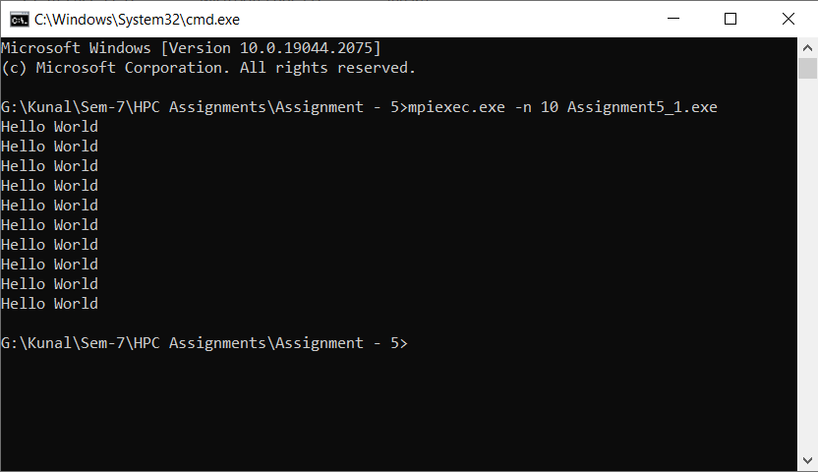

**Information #:**

#include <mpi.h>

#include <stdio.h>

/* run this program using the console pauser or add your own getch, system("pause") or input loop */

int main(int argc, char** argv)

{

//Initialize the MPI environment

MPI_Init(NULL,NULL);

printf("Hello World\n");

//Finalize the MPI environment

MPI_Finalize();

return 0;

}

**Problem Statement 2:**

Implement a program to display rank and communicator group of five processes

**Screenshot #:**

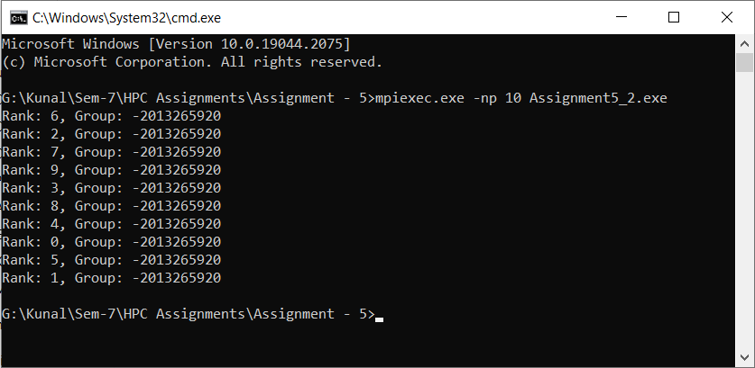

**Information #:**

#include <mpi.h>

#include <stdio.h>

/* run this program using the console pauser or add your own getch, system("pause") or input loop */

int main(int argc, char** argv)

{

//Initialize the MPI environment

MPI_Init(NULL,NULL);

//Get the rank of process

int rank;

MPI_Comm_rank(MPI_COMM_WORLD, &rank);

MPI_Group group;

MPI_Comm_group(MPI_COMM_WORLD, &group);

printf("Rank: %d, Group: %d \n", rank, group);

//Finalize the MPI environment

MPI_Finalize();

return 0;

}

**Github Link:**

<https://github.com/Kunalkadam179/HPC-Assignment/tree/main/Assignment%20-%205>